Information for people who are self-isolating

Staying at home for long periods of time can be hard, frustrating, and lead to loneliness which may lead to you feeling low. It can be very challenging if you do not have much room or access to a garden.

Being asked to avoid social contact is a hard challenge, one which many have never been asked to do before. You may be asked by the government, the NHS, or your employer to stay at home to help limit the spread of the virus. By doing this we can all do our part to protect those who are most vulnerable in society and make sure the NHS is not overwhelmed, as can be seen in the graph below.

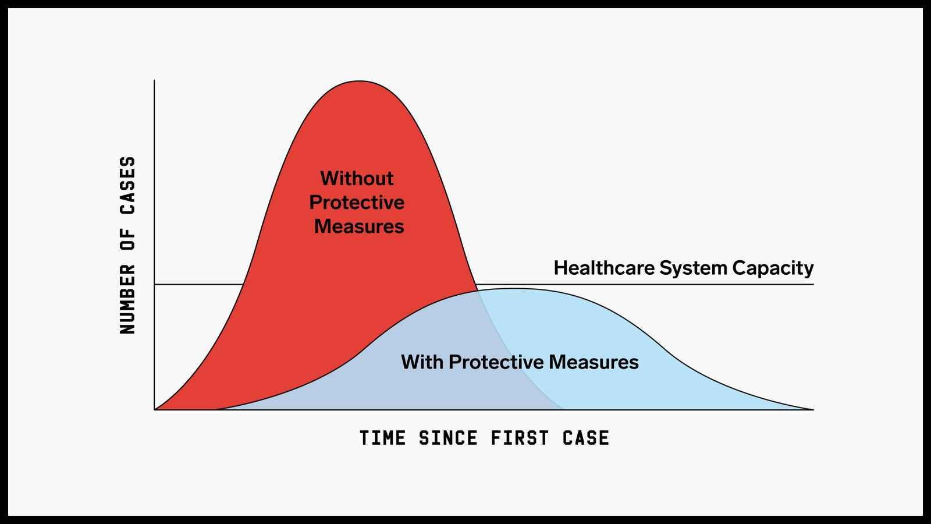

Seek prompt medical attention if your illness or the illness in any household members is worsening. If it’s not an emergency, contact NHS 111 online at 111.nhs.uk. If you have no internet access, you should call NHS 111. If it is an emergency and you need to call an ambulance, dial 999 and inform the call handler or operator that you or your relative have coronavirus symptoms

Wash your hands often
- Clean your hands frequently each day by washing with soap and water for 20 seconds or using hand sanitiser. This will help protect you and the people you live with. This step is one of the most effective ways of reducing the risk of passing infection to others.

Cover your coughs and sneezes
- Cover your mouth and nose with disposable tissues when you cough or sneeze. If you do not have one to hand, sneeze into the crook of your elbow, not into your hand.

- If you have a carer, they should use disposable tissues to wipe away any mucus or phlegm after you have sneezed or coughed. Then they should wash their hands with soap and water.

- Dispose of tissues into a disposable rubbish bag and immediately wash your hands with soap and water or use a hand sanitiser.

What is Self Isolation:

FOR PEOPLE WHO ARE CONSIDERED VULNERABLE:

• aged 70 or older (regardless of medical conditions)
• under 70 with an underlying health condition listed below (i.e. anyone instructed to get a flu jab as an adult each year on medical grounds):
• chronic (long-term) respiratory diseases, such as asthma, chronic obstructive pulmonary disease (COPD), emphysema or bronchitis
• chronic heart disease, such as heart failure
• chronic kidney disease
• chronic liver disease, such as hepatitis
• chronic neurological conditions, such as Parkinson’s disease, motor neurone disease, multiple sclerosis (MS), a learning disability or cerebral palsy
• diabetes
• problems with your spleen – for example, sickle cell disease or if you have had your spleen removed
• a weakened immune system as the result of conditions such as HIV and AIDS, or medicines such as steroid tablets or chemotherapy
• being seriously overweight (a BMI of 40 or above)
• those who are pregnant

If you to self-isolate, you will need to get to the place you are going to stay using your normal mode of transport, once there remain indoors and avoid contact with other people. This will prevent you from spreading the disease to your family, friends and the wider community.

In practical terms, this means that once you reach your residence you must:

- stay at home
- not go to work, school or public areas
- not use public transport like buses, trains, tubes or taxis
- avoid visitors to your home
- ask friends, family members or delivery services to carry out errands for you - such as getting groceries, medications or other shopping

If you have a vulnerable person living with you please try to minimise contact with them where reasonably possible:

- aim to keep 2 meters away from them and encourage them to sleep alone
- If possible use separate bathrooms and towels for both showering/bathing and hand washing
- If you do share a bathroom try to clean it everytime it is used and make note of what surfaces you touch including handles, lights, taps, etc.
- When using a kitchen try to avoid doing so if they are around. Wash all items as soon as you can and try to keep cutlery and crockery separate for a vulnerable person. Wash and dry thoroughly with a clean towel each time, making sure your hands are clean.

Social distancing measures are steps you can take to reduce the social interaction between people. This will help reduce the transmission of coronavirus (COVID-19).

They are:

- Avoid contact with someone who is displaying symptoms of coronavirus (COVID-19). These symptoms include high temperature and/or new and continuous cough

- Avoid non-essential use of public transport, varying your travel times to avoid rush hour, when possible

- Work from home, where possible. Your employer should support you to do this. Please refer to employer guidance for more information

- Avoid large gatherings, and gatherings in smaller public spaces such as pubs, cinemas, restaurants, theatres, bars, clubs

- Avoid gatherings with friends and family. Keep in touch using remote technology such as phone, internet, and social media

- Use telephone or online services to contact your GP or other essential services

We know how hard this may be but the aim is to protect the most vulnerable.

There is a guide at the end of this to help determine when to end isolation.

Things to think about:

It is important to take good care of your mind as well as your body and there are some things you can do to help with this. Staying in touch with friends and family is important and the ability to reach out to others for help, or to give help, can be a positive mental health benefit.

There is a lot of information on the Every Mind Matters website, which you can find at https://www.nhs.uk/oneyou/every-mind-matters/

Having a mind-set where you have choice and control is beneficial for seeing through this difficult time. Having a structure and engaging in activities such as cooking, reading, learning a new skill, or watching films can be positive for your wellbeing. Many entertainment companies and service providers are working towards increasing resources for people during this difficult time. It is worth looking to see what is available.

Mental health can be an ongoing challenge for many and people can be significantly affected by having to stay isolated with limited options to interact with others or go about your daily routine. There are a number of things you can do to help maintain your mental health with lots of resources available to give information and advice.

- Keep in touch with people – family and friends will be as pleased to hear from you as you are from them. Arrange times to call or contact one another to help ensure everyone is as well as we could be. If you’re worried about what to talk about, maybe watch the same TV show and comment to one another, or read a book.

- There are many options to connect with others and it is important to know that you and others are not alone, and that you can make a difference.
  - If there aren’t people you can talk to or would like more opportunity to talk to others there are services and charities which may be available to you. Using online resources can be a great advantage to connect with others and provides a great flexibility to be there when you need it.
  - Some examples of services include:
      - Big White Wall - https://www.bigwhitewall.com/
        - an online service providing access to millions with anxiety, depression and other common mental health issues
      - Samaritans – https://www.samaritans.org/
        - 116 123
        - providing emotional support to anyone in emotional distress, struggling to cope, or at risk of suicide
      - Elefriends - https://www.elefriends.org.uk/
        - Elefriends is a supportive online community where you can be yourself. We all know what it’s like to struggle sometimes, but now there’s a safe place to listen, share and be heard.
        - This service is also available via mobile app.
      - Silverline - https://www.thesilverline.org.uk/
        - free confidential helpline providing information, friendship and advice to older people, open 24 hours a day, every day of the year
        - 0800 4 70 80 90

There are many services out there which can found online.

Keeping stimulated:

- Learning new skills can be achieved through online courses or borrowing digital books through your library

  - Some examples of online learning platforms are:

- Futurelearn - https://www.futurelearn.com/courses/online-learning

- Open Learn - https://www.open.edu/openlearn/free-courses

- EdX - https://www.edx.org/

- Similarly there are many entertainment and learning opportunities on sites such as You Tube.

- Entertainment – With many TV, movie, and radio services, there is a wide variety of entertainment available for many people. You may be able to get a free trial of some services if there are concerns about cost.

The right places:

- Thinking about what rooms you have, what you use them for, and what you don’t want to use them for is essential. Living with others can be just as challenging so you may want to ask others and agree a way which works best for all.

- Working from home is a massive challenge for many with issues like motivation, boredom, and lack of support being issues people face. To better manage this potential need you may want to think of an exclusive place to work, maybe by setting up a small office space in the corner which you can retreat from when you are finished.

- Rooms such as bedrooms are ones which we associate with rest and relaxation. To work in these is best avoided (where possible) to ensure there is a place where you go to in order to get that essential rest that we all need. Remember that if you are living with others you may need space for yourself. Trying to find a place that you can go to can be essential to maintain positive mental health.

- Keeping you environment in a manner which you feel most comfortable would be beneficial to your wellbeing. Keeping things clean and tidy will help reduce clutter and frustrations, and whilst this can be different for each person when living with others it can be essential to maintain good relationships.

- The NHS has advice about self isolating at home and trying to reduce the spread of the virus:
https://www.nhs.uk/conditions/coronavirus-covid-19/self-isolation-advice/

Self care:

- Understanding that your body and wellbeing is a priority will help inform better decision making with some basics such as staying hydrated and eating a balanced and varied diet being essential. You may want to look at changing your routines whilst self-isolating to something that could work better for you.

- Exercise can be difficult in small spaces but getting fresh air or going outside into a garden is positive for wellbeing. If able, try to exercise at home where you can. It will offer further structure to your days and contribute to maintaining a healthy lifestyle, giving you opportunity to work out frustrations and help increase positive feelings through the release of endorphins.
- Be mindful of your surroundings, other people, and limitations – don’t overdo it, just do what you can, if you can.

- Maintaining hygiene is essential to most people so be mindful about keeping up your routine and ensuring your surrounds are clean where possible. It will help stop the virus and contributes to a feeling that you can do something to help. Maintain a laundry cycle, to help stop potential areas where germs can accumulate and put things away, where possible.

- If you do not have a washing machine, wait a further 72 hours after your 7-day (for individual isolation) or 14-day isolation period (for households) has ended when you can then take the laundry to a public launderette.

- The NHS has information about how to prevent the spread of germs: https://www.nhs.uk/live-well/healthy-body/how-to-prevent-germs-from-spreading/

- Medication may be a concern for you. If you are self isolating please contact you GP surgery and/or pharmacy for further information. You may be able to order medication over a phone.
- Keeping taking your medication as normal until otherwise instructed by a clinician.

Call 111 if you have any concerns about accessing medication.

Bills and worries:

There can be many worries about money and bills.

- If you are employed and asked to self isolate or work from home you may be worried about your job, if you’ll be paid, and what you may be paid. The Citizens Advice have a page about Coronavirus (Covid19) and how this may affect you, including information about what your rights may be about your work and potential benefits available to you:
https://www.citizensadvice.org.uk/health/coronavirus-what-it-means-for-you/

- If you are worried about paying bills it may be a good idea to look on a service provider’s website or call them to see who they are managing the situation and what options may be open to you. Remember that if your income drops you may become entitled to additional support.

- West Berkshire no longer have a welfare assistance scheme to be able to contact for onging support but the Citizens Advice has information which you find useful:
https://www.citizensadvice.org.uk/benefits/help-if-on-a-low-income/if-youre-struggling-with-living-costs/

- You may become entitled to benefits during the current crisis so it may be beneficial to undertake a check:

- Turn2Us - https://benefits-calculator.turn2us.org.uk/AboutYou

- Entitledto - https://www.entitledto.co.uk/?e2dwp=y

- Policy in Practice - https://www.betteroffcalculator.co.uk/free

- There are additional advice services which are available for people to contact:

- Citizens Advice - 0300 222 5941

- AgeUk Adviceline - 0800 678 1602

- Dependant on your circumstances or health conditions there may be additional advice services available to reflect these, which can easily be found online.
Examples of these include:

- Gingerbread - 0808 802 0925 – an advice service for single parents.

- Unison - 020 7121 5620 – advice for members of the Unison union

- MacMillan - 0808 808 00 00 – Advice for people affected by cancer.

- Your circumstances may enable more information advice services available so please look if your feel you may be able to benefit.

- Additional advice services may be available via webchat or email also.

- Consider whether you may now be entitled to support for your council tax. You can look on West Berks website for information or call them on 01635 519520, or email on counciltax@westberks.gov.uk

Food:

This may be a concern for many to be able to get the essential in. Currently the shops are open but there is no guarantee of this so if someone is able to shop for you that may be best. Friends and family may be able to do some shopping for you.

Foodbanks may be able to assist but will be subject to intense demand. West Berks Foodbank can be found
https://westberks.foodbank.org.uk/ and contacted on 07955 626621 but you may be asked to contact an approved signatory.

Work:

Your rights whilst self-isolating can be found on various website and advice lines if you are worried. It may be good to consider reading up on where you stand to give yourself some clarity and certainty.

- You can find information on sites such as:
  - Gov.uk

  - Citizens Advice

  - Acas

  - Shelter

Any website of union you may or may not be a part of. Please be aware certain occupations may have differing requirement and obligations, or there may be different arrangements in place.

If you have any concern about losing your job or you are worried about discrimination, please call ACAS on 0300 123 1100.

Appointments:

Arranged appointments may be cancelled or amended due to the outbreak so please contact them to check what is happening and what you may need to do.

Care/caring:

If you are in receiving care please make contact with your provider to understand what is happening for you and to see what you may need to do, or not do, to help keep safe.

If you are a carer and have concerns please feel free to contact your Social Prescriber at your GP surgery to discuss concerns and potential assistance that may be out there. You are not alone.

Advice for informal carers:

- If you are caring for someone who is vulnerable, there are some simple steps that you can take to protect them and to reduce their risk at the current time.

- Ensure you follow advice on good hygiene such as:

- wash your hands on arrival and often, using soap and water for at least 20 seconds or use hand sanitiser

- cover your mouth and nose with a tissue or your sleeve (not your hands) when you cough or sneeze
- put used tissues in the bin immediately and wash your hands afterwards

- do not visit if you are unwell and make alternative arrangements for their care

- provide information on who they should call if they feel unwell, how to use NHS 111 online coronavirus service and leave the number for NHS 111 prominently displayed

- find out about different sources of support that could be used and access further advice on creating a contingency plan is available from Carers UK

- look after your own well-being and physical health during this time. Further information on this is available here

Please consider your own wellbeing as important as those your care for. There are services available for support with Reading and West Berkshire Carer’s Hub being well placed to assist with the needs of carers and any issues they have.

http://www.berkshirecarershub.org/

0118 324 7333

