The NHS and the Learning Disability Partnership Board invites you to our Health Check and Wellbeing Information Drop In
 | Thursday 16 June 2022
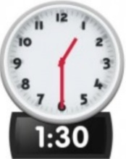  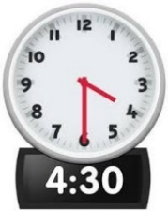 | From 1.30pm to 4.30pm  This event is a drop in, so you don’t need to stay the whole time.
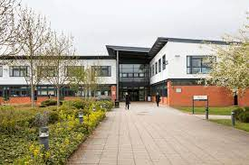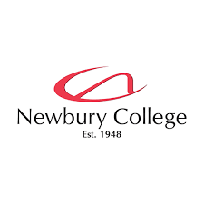 | At The Training Restaurant  Newbury College  Monks Lane  Newbury  RG14 7TD
Come and talk to us about

Health checks
Healthy eating
Exercise
Blood pressure
Mental Health
 | Light refreshments will be available.
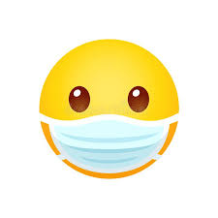 | Staff will be wearing a mask. It is your choice if you want to wear one.
If you have any questions, you can call your GP Practice.

You do not need to tell us if you are coming.

